## Front End Engineering-II

Project Report

Semester-IV (Batch-2022)

**Real Estate**

**Supervised By: Submitted By:**

Ms. Preenu Mittan Gurpreet Kaur (2210991597)

Harshit Malik (2210991637)

Hasika (2210991649)

Himanshi (2210991655)

**Department of Computer Science and Engineering**

Chitkara University Institute of Engineering & Technology,

Chitkara University, Punjab

**Abstract**

Real estate has proved to be a real engine of growth. The real estate sector in India is emerging as the next engine of economic growth going by the fact that it is the second largest employer next only to agriculture. It has significant linkages with several other sectors and over 250 associated industries. According to estimates, every rupee invested in this sector results in 78paisa being added to the GDP. Accordingly, a unit increase in expenditure has a multiplier effect and the capacity to generate income is as high as five times. For instance, if the economy grows at the rate of 10%, the sector has the capacity to grow at 14% and generate 3.2 million new jobs over a decade . The sector size is close to $12bn and grows at 30% per annum. Presently, it is contributing 5% of the country's GDP and is expected to rise up to 6% within three to four years. The present project has been carried out with the objective of analyzing the financial aspects related to the real estate.33

**Table of contents**

|  |  |  |
| --- | --- | --- |
| **S.no** | **Topics** | **Page No.** |
| **1.** | **Introduction** | **4-7** |
| **2.** | **Problem Definition** | **8-9** |
| **3.** | **Proposed Design/ Methodology** | **10-12** |
| **4.** | **Scope** | **13-14** |
| **5.** | **Results** | **15-18** |
| **6.** | **Conclusion** | **19** |

**1.Introduction:**

The term real estate is defined as land, including the air above it and the group below it, and any building or structure on it is also referred to as realty. It covers residential housing, commercial offices, and trading spaces such as theater, hotels, and restaurant retail outlets, industrial buildings such as factories and government buildings. Real estate involves the purchase, sale and development of land, residential and non-residential buildings. The main players in the real estate market are the landlords, developers, builders, real estate agents, tenants, buyers etc. The activities of the real estate sector encompass the housing and construction sectors also. The real estate sector in India has assumed growing importance with the liberalization of the economy. The consequent increase in business opportunities and migration of the labor force has, in turn, increased the demand for commercial and housing space, especially rental housing. Developments in the real estate sector are being influenced by the developments in the retail, hospitality and entertainment (e.g.: Hotels, resorts, cinema theatre) industries, economies services and information technology (IT)enabled services etc. The real estate sector is a major employment driver, being the second largest employer next only to agriculture. This is because of the chain of backward and forward linkage that the sector has with the other sectors of economy, especially with the housing, construction and commercial sector. About 250 ancillary industries such as cement, steel, brick, timber, building material etc are dependent on the real estate industry**.**

* 1. **Background:**

Before the widespread use of real estate websites, the scenario was quite different:

People had to visit physical real estate offices to inquire about properties, which limited access to information. Properties were advertised in newspapers, magazines, and brochures, making it difficult to reach a wide audience. People relied on referrals and word of mouth to find properties. Access to property details, photos, and virtual tours was restricted. Buyers and renters had to physically visit properties, wasting time and effort. Real estate agents and developers had limited reach, mostly catering to local clients. Leads and inquiries were generated through phone calls, emails, or physical visits. Agents had to manually update property listings, which was time-consuming and prone to errors. There was no easy way to track user behavior, preferences, or market trends. Communication between agents, clients, and stakeholders was slower and less efficient. The advent of real estate websites revolutionized the industry, making it easier for buyers, renters, and real estate professionals to connect, access information, and conduct business.

* 1. **Objectives:**

The primary objectives of a real estate website include:

1. Showcase properties: Displaying properties for sale or rent, with detailed information and visuals.

2. Lead generation: Capturing inquiries and leads from potential buyers and renters.

3. Market reach: Expanding the reach of the real estate business to a wider audience, locally and globally.

4. Brand establishment: Establishing the brand identity and credibility of the real estate company.

5. Property search: Providing an easy-to-use search functionality for users to find properties based on various criteria.

6. User engagement: Offering features like property comparisons, favorites, and saved searches to enhance user experience.

7. Data analysis: Tracking user behavior, preferences, and market trends to inform business decisions.

8. Customer support: Providing resources, FAQs, and contact information for customer inquiries.

9. Competitive advantage: Standing out from competitors by offering a user-friendly and informative website.

10. Revenue growth: Driving revenue through property sales, rentals, and advertising.

11. Building trust: Providing accurate and up-to-date information to build trust with potential clients.

12. SEO optimization: Improving search engine rankings to increase visibility and organic traffic.

By achieving these objectives, a real estate website can effectively support the business goals of a real estate company.

* 1. **Significance:**

A real estate website has significant importance in today's digital age:

1. Increased online visibility: A website makes your business visible to a global audience, 24/7.

2. Credibility and trust: A professional website establishes your brand's credibility and trustworthiness.

3. Property showcase: A website allows you to showcase properties in an attractive and detailed manner.

4. Lead generation: A website captures leads and inquiries, helping you connect with potential clients.

5. Competitive advantage: A website sets you apart from competitors and establishes your brand's online presence.

6. Cost-effective marketing: A website is a cost-effective marketing tool, reducing the need for physical brochures and print ads.

7. Data analysis: A website provides valuable insights into user behavior and preferences, helping you refine your marketing strategy.

8. Customer engagement: A website enables you to share news, updates, and market insights, fostering a relationship with clients and potential customers.

9. Time-saving: A website automates many tasks, saving you time and effort.

10. Scalability: A website can handle a large volume of traffic and inquiries, making it an ideal solution for growing businesses.

11. SEO benefits: A website optimized for search engines improves your visibility in search results.

12. 24/7 availability: A website operates around the clock, providing information and answering queries even outside business hours.

By having a real estate website, you can stay competitive, increase visibility, and connect with clients in the digital age!

**2. Problem Statement:**

The real estate industry is facing challenges in effectively showcasing properties, managing inquiries, and analyzing user behavior. The current process is manual, time-consuming, and prone to errors. The industry needs a digital solution that can provide an intuitive property search and filtering system. Showcase properties with detailed information, high-quality images, and virtual tours. Manage inquiries and leads efficiently. Offer valuable insights and analytics on user behavior and market trends. Ensure data accuracy, security, and compliance with regulatory requirements.

**2.1** **Software requirements:**

Here are the hardware and software requirements for building a real estate website:

**Hardware Requirements:**

1. Server:

- CPU: Quad-core or higher

- RAM: 8 GB or more

- Storage: 256 GB or more (SSD recommended)

2. Database Server:

- CPU: Quad-core or higher

- RAM: 8 GB or more

- Storage: 512 GB or more (SSD recommended)

**Software Requirements:**

1. Operating System:

- Windows Server (optional)

2. Programming Languages:

-JavaScript

-React

3. Database Management System:

- MongoDB

4.Authentication:

-Firebase

5. Mapping and Location-Based Services:

- Google Maps

**3. Purposed Design:**

**“**Your home, our priority - explore the best real estate options with **Housetica**”

1. Clear Navigation and Search:

- Easy-to-use search bar with filters (location, price, property type, etc.)

- Clear navigation menu with categorized links

2. Prominent Property Listings:

- High-quality property images and virtual tours

- Detailed property information (description, features, amenities, etc.)

- Call-to-action buttons (Schedule a Viewing, Get More Info, etc.)

3. User-Friendly Search Results:

- Grid or list view options

- Sorting and filtering options (price, location, etc.)

- Property comparison feature

4. Property Details Page:

- Detailed property information

- High-quality images and virtual tours

- Map view with nearby amenities

- Agent contact information

5. Testimonials and Reviews:

- Customer testimonials and reviews

- Ratings and reviews from reputable sources (e.g., Yelp)

6.. Contact and Inquiry Forms:

- Easy-to-use contact forms

- Quick inquiry forms for property listings

7.. Mobile Optimization:

- Responsive design for smartphones and tablets

- Easy navigation and search on mobile devices

8. Social Media Integration:

- Social media links and sharing buttons

- Social media feeds and updates

**Schematic Diagram:**

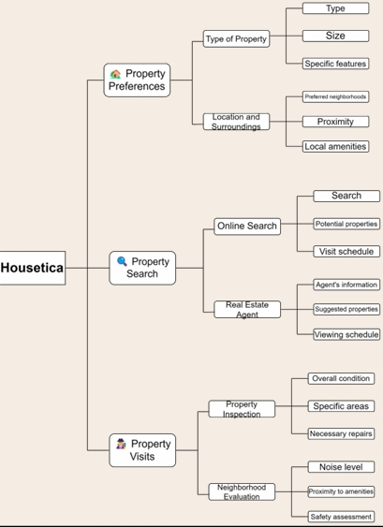

Fig1.1

**Methodology:**

The methodology of a real estate website involves a strategic and systematic approach to create an effective online platform. It begins with planning and research, defining the website's purpose and target audience, and conducting market research and competitor analysis. This is followed by design and prototyping, creating wireframes and mockups, and developing a visual design concept. Content creation involves developing a content strategy and creating engaging and informative content, optimized for search engines. Development involves building the website implementing necessary features and functionalities, and ensuring responsive design and mobile-friendliness. Testing and quality assurance involve thorough testing, identifying and fixing bugs, and ensuring website security and data privacy. Launch and deployment involve launching the website, making updates, and monitoring performance and user feedback. Maintenance and updates involve regularly updating content and features, monitoring performance, and implementing new technologies and features. Finally, marketing and promotion involve developing a marketing strategy, utilizing social media and other channels, and analyzing user behavior to adjust marketing efforts. By following this methodology, a real estate website can effectively attract, engage, and convert users into clients.

**4. Scope:**

The scope of a real estate website can include:

1. Property Listings:

- Residential and commercial properties for sale or rent

- Detailed property information, images, and virtual tours

2. Search and Filter:

- Advanced search functionality with filters (location, price, property type, etc.)

- Sorting and ranking options

3.. Property Management:

- Tools for property owners and managers to manage listings and inquiries

4. User Accounts and Profiles:

- User registration and login functionality

- Personalized dashboards and saved searches

5. Inquiries and Leads:

- Contact forms and email notifications for inquiries

- Lead management system for agents and agencies

6. Testimonials and Reviews:

- Customer reviews and ratings

- Testimonials from satisfied clients

7. Social Media Integration:

- Social media links and sharing buttons

- Social media feeds and updates

8. Mobile Optimization:

- Responsive design for mobile devices

- Mobile-friendly search and listing views

9. API Integration:

- Integration with third-party APIs for data and services

Overall, the scope of the real estate website is to provide a robust and efficient online platform that streamlines property transactions and enhances the overall user experience.

**5.Result:**

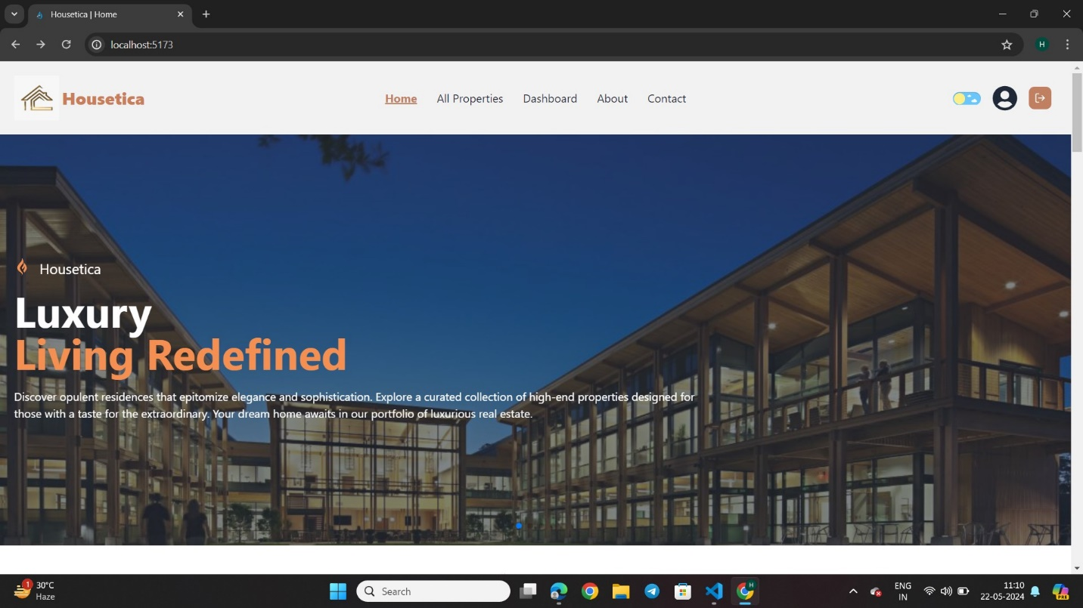

**Fig 5.1**

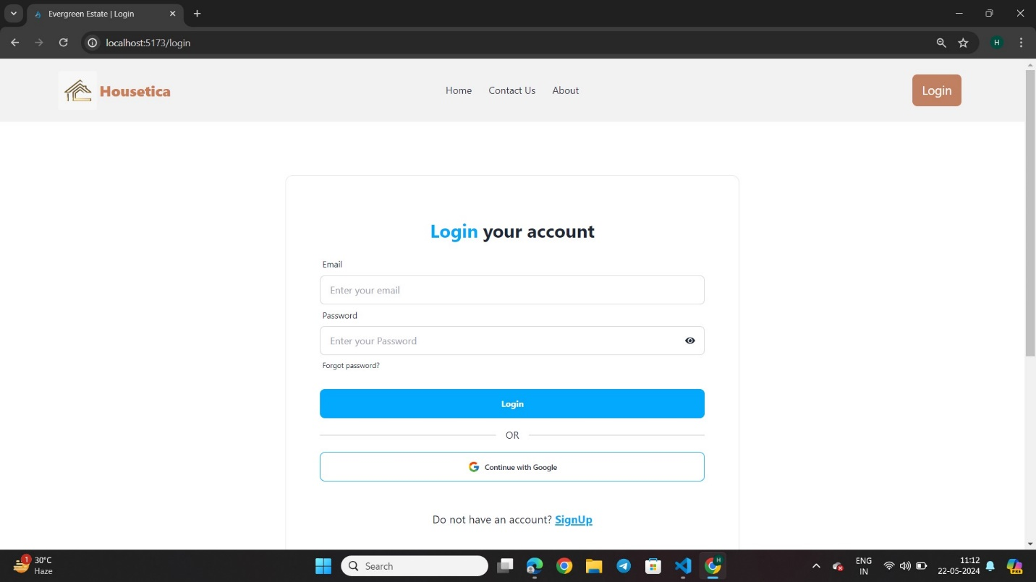**Fig 5.2**

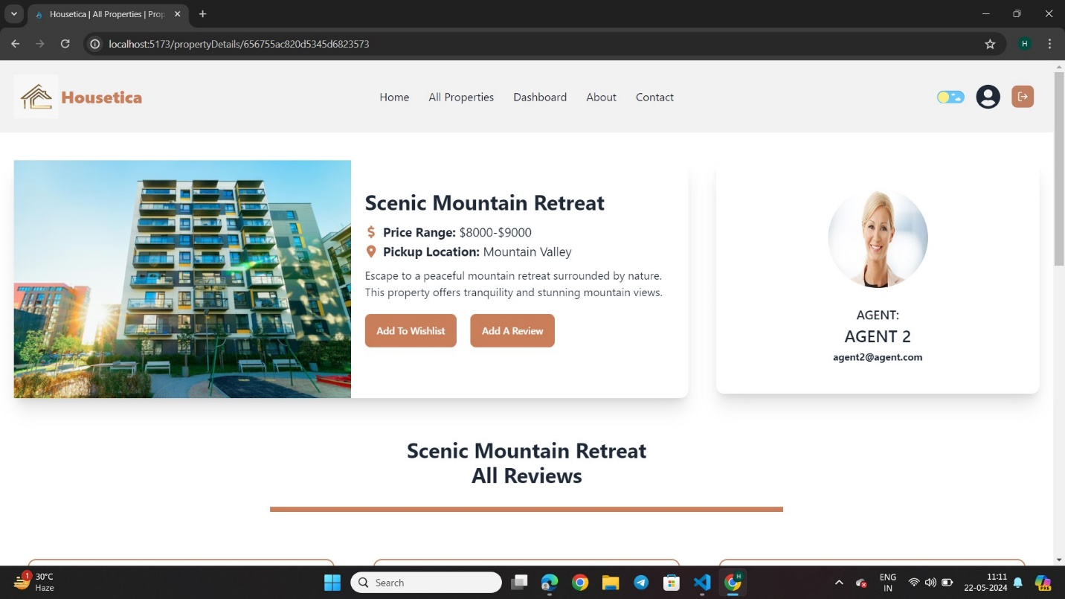**Fig5.3**

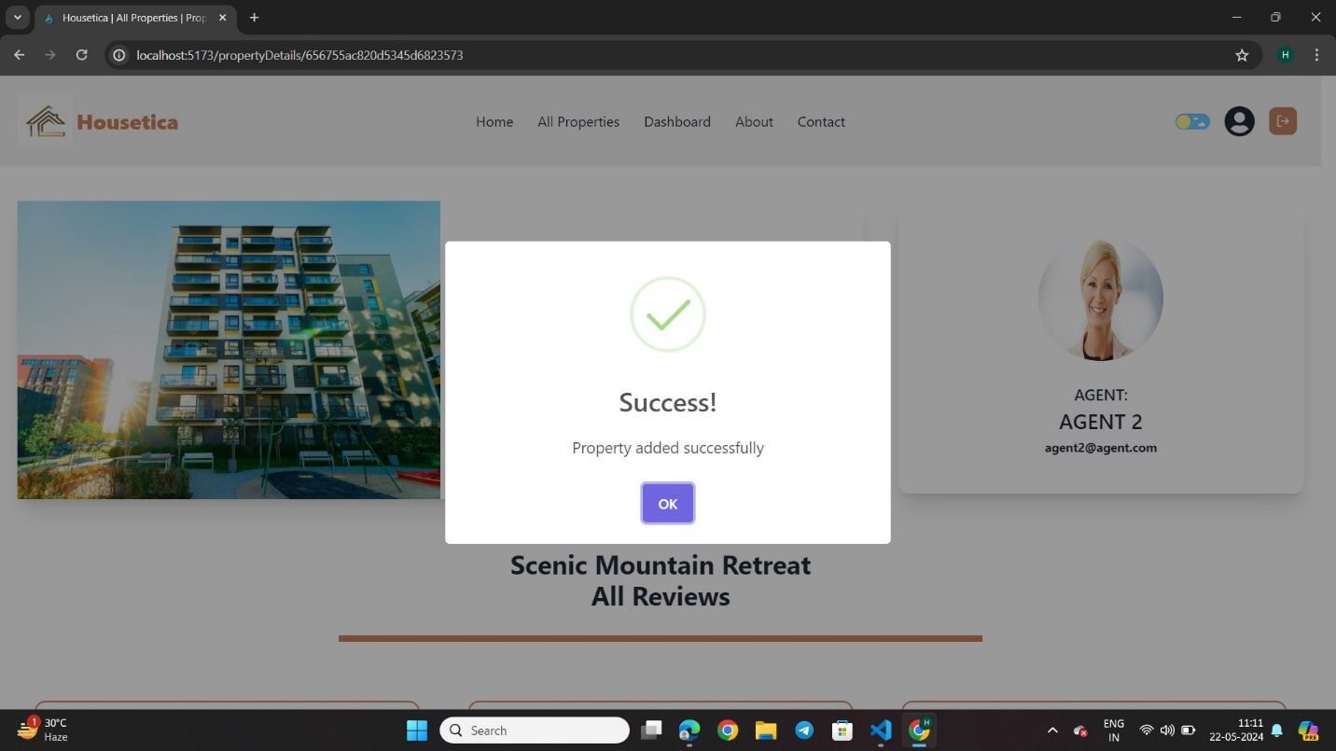

**Fig5.4**

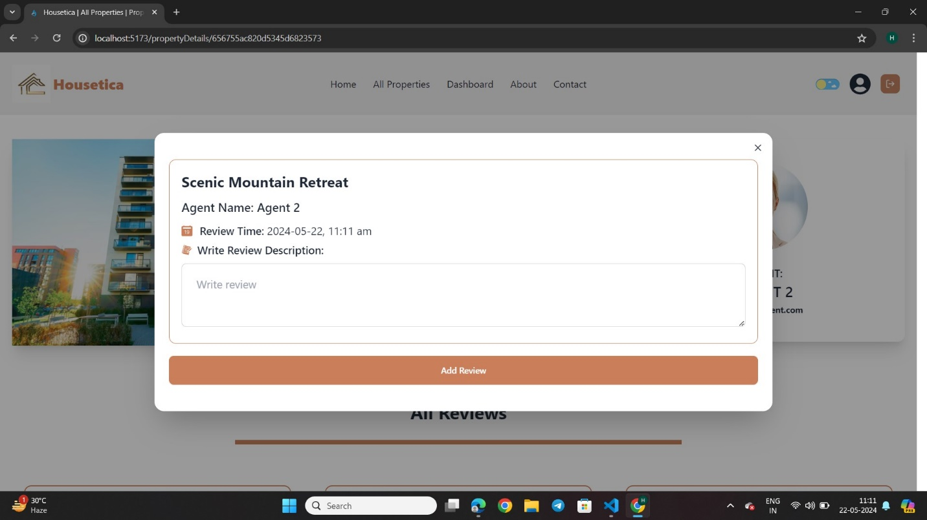

**Fig5.5**

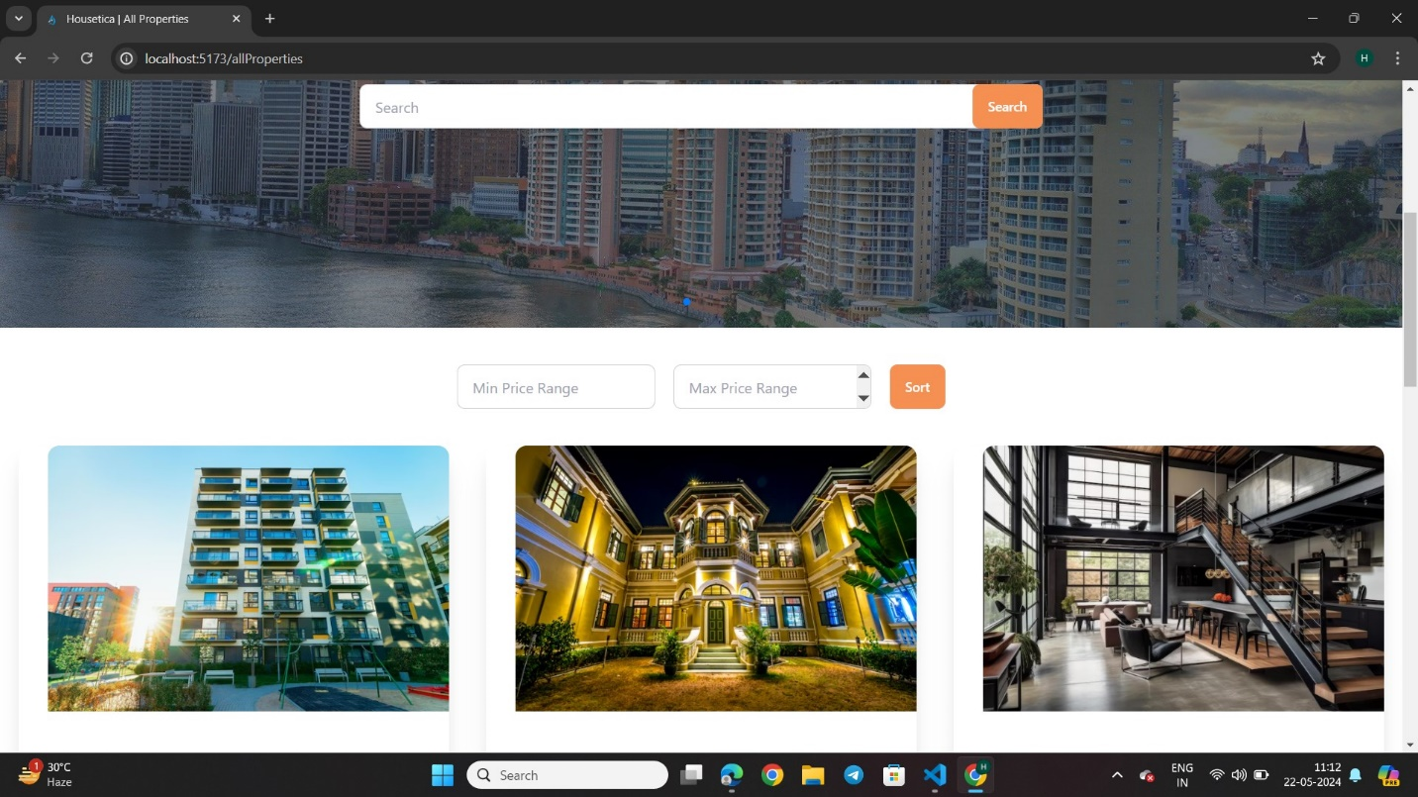

**Fig5.6**

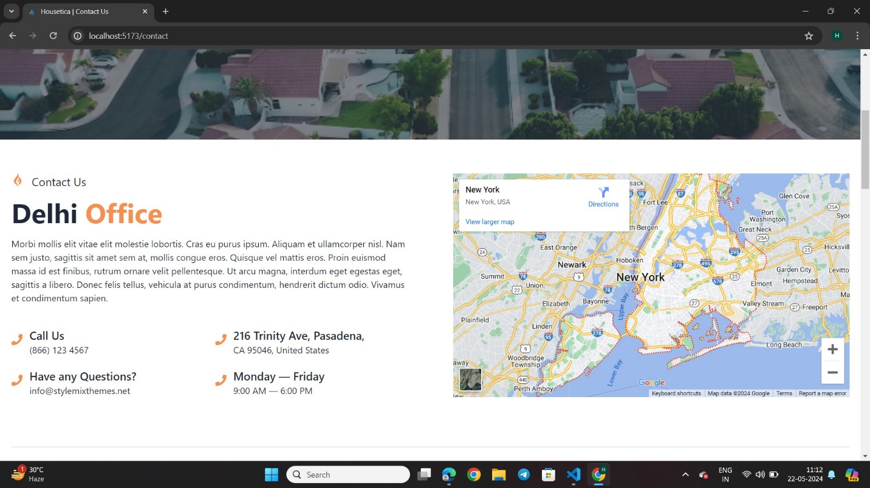

**Fig 5.7**

**6.Conclusion:**

In conclusion, the real estate website is a cutting-edge online platform designed to revolutionize the way people buy, sell, and interact with properties. With its user-friendly interface, comprehensive property listings, and advanced search functionality, the website provides an unparalleled user experience. The website's scope includes features such as agent and agency management, property management, payment gateway integration, and analytics and reporting tools, making it a one-stop-shop for all real estate needs.

By leveraging the latest technology and industry expertise, the website aims to make property transactions faster, easier, and more secure. Whether you're a property seeker, an agent, or an investor, this website is the ultimate destination for all your real estate requirements.

With its commitment to innovation, customer satisfaction, and excellence, the real estate website is poised to transform the industry and set new standards in online property transactions. Join the journey today and experience the future of real estate!